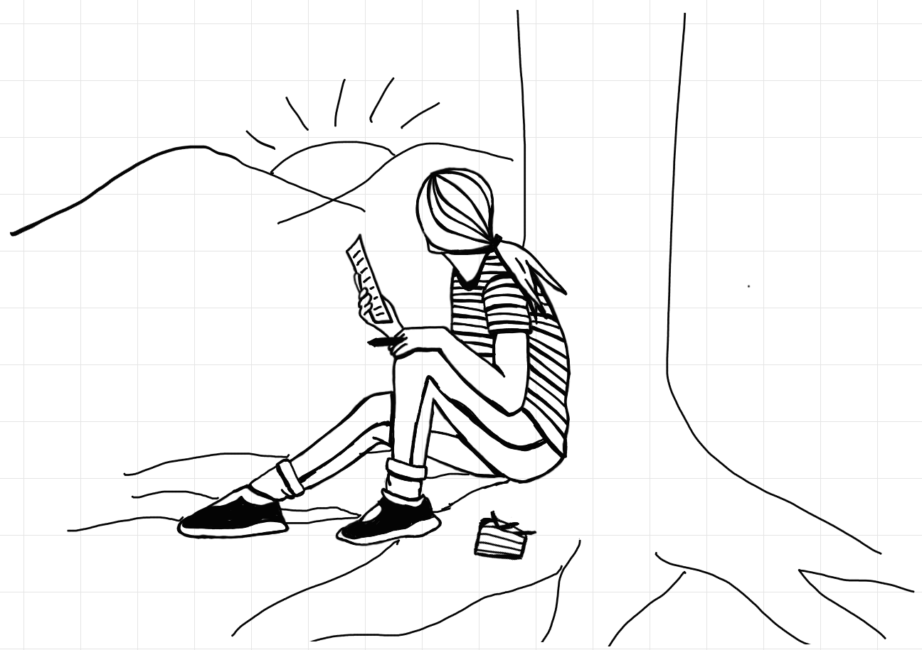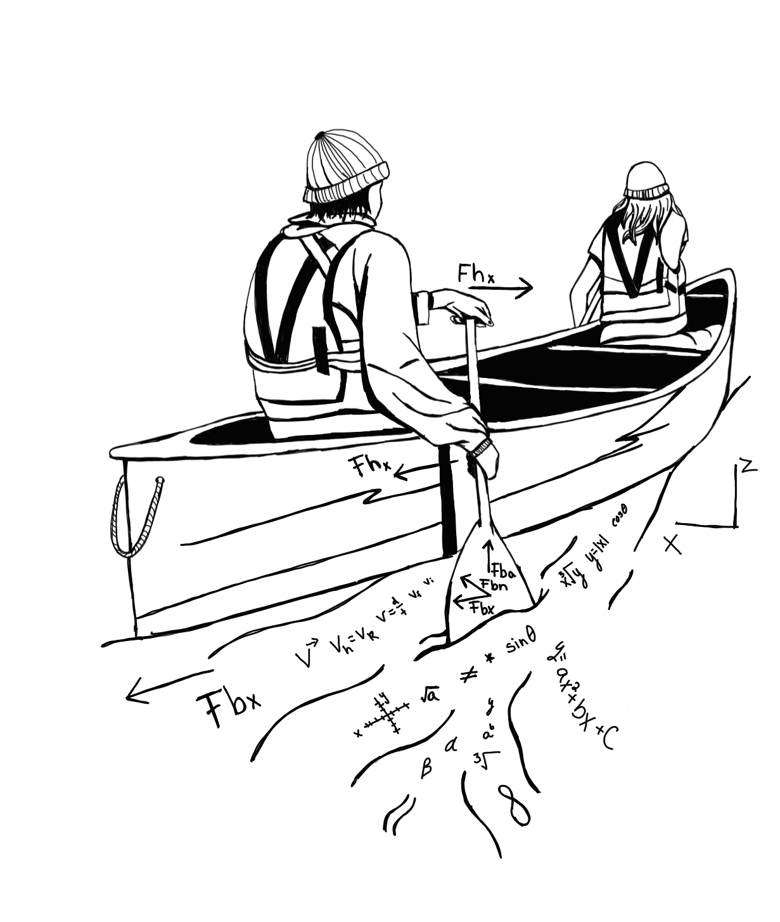 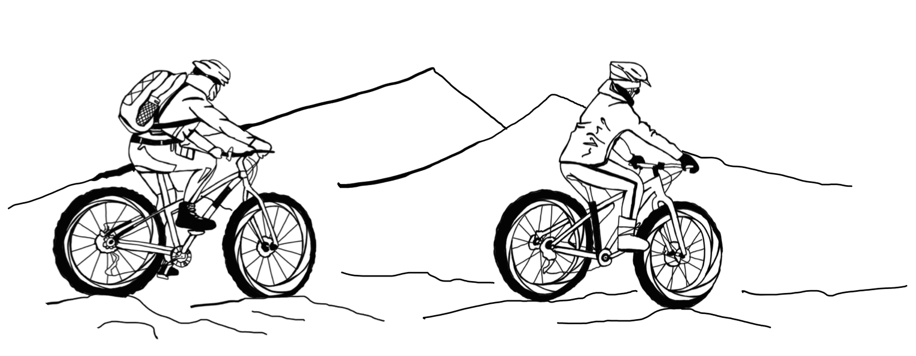

**STUDENT INFORMATION**

Student full name ____________________________

Community __________________________________

Date of birth _________________________________

Student cell phone ___________________________  
Home phone _________________________________

Home school _________________________________

List of current teachers ______________________

_______________________________________________

_______________________________________________

Student email ________________________________  
Student signature ____________________________

Date _____________________

Parent/guardian signature ___________________

Date _____________________

Parent/guardian name (print) _______________________________________________

Parent 1 contact #____________________________

Email: _________________________________

Parent 2 contact # __________________________

Email: _________________________________

**APPLICATION PROCESSES**

Submit this completed application form and send me a brief video (2-3 minutes) describing why you would be a good fit for the program and why you are interested in learning in this way; including some sort of interesting artistic aspect will go a long way. Include a complete list of your current teachers. Your application can be delivered to Anthony.grottoli@yesnet.yk.ca or in person at the FH Collins front office by January 29th. See Mr. Grottoli in room 122 at FH Collins if you have any questions.

**GENERAL DESCRIPTION**

*What is it?*

The STEAM program is an integrated semester in French Immersion offering four different courses. It gives students the opportunity to discover and learn outside the classroom through creative and positive hands-on learning experiences. The program endeavours to develop physical, intellectual, social, emotional, and cultural aspects of their personality. Outdoor experiences are used to understand concepts of physics, mathematics, media production as well as gain an understanding and appreciation of the land on which we live, thus fostering a culture of stewardship.

### Sciences, Technology, Engineering, Arts and Mathematics

### (French Immersion)

**2024-2025**

### *General application*

**STEAM**

quadratics, rationals, trigonometry and more, as well as an applied look at finances. Broadly speaking, Pre-Calculus 11 is focused on the continued development of algebraic and critical thinking, problem solving and the application of mathematics in real-life situations.

**Physique 11 -** This course will help students come to both a conceptual and mathematical understanding of kinematics, dynamics, energy & momentum, waves & optics. As much as possible, these topics will be explored through an engineering lens and augmented with technological applications.

**Plein Air 11 -** Students in this program will learn and develop skills in a complex and dynamic outdoor environment while participating safely and developing teamwork skills. Activities such as mountain biking, surfing, canoeing and hiking may be used to develop outdoor skills. First peoples’ traditional practices and traditional knowledge will be shared with students. Being stewards of the land with a conservational approach will also be part of this class.

**Art Médiatique 11 -** This program will help you to grow as an artist in term of expression, creativity, and identity. The course will look at different technological media and help you with pre & post-production skills as well as on-site considerations toward a final product. Materials, processes, and technics of media art will also be a central theme of the learning. Students will integrate other classes into their personal media projects throughout the semester.

**REQUIREMENT**

* Interested to learn and willing to try new things
* Skills and abilities in the outdoors is not a requirement, as it will be developed in the program. However, we suggest students have at least an intermediate comfort level riding a mountain bike prior to the program.
* *Sciences 10*, *Fondements de Maths et Pré-calcul 10* are basic requirements for applying to the program
* We will adapt activities according to physical abilities and health considerations

**STUDENT’S EXPECTATION**

Students applying to the program will be expected to take part in field activities, as well as extended trips, as they are an integrated part of the program.

**TRIPS AND CLASS TIME**

A maximum of 25 days will be spent on overnight trips away from the school, not including Field day activities. The rest of the days will be normal classroom time learning theorical concepts.

**YOUR STEAM YEAR**

**Steam semester**Physique 11, Pré-calcul 11,   
Plein Air 11, ArtMédiatique 11,

**Alternate semester**English 11   
Français 11 One Science 11 One additional elective

**SAFETY**

The safety and well-being of the students is always the first and most important consideration when taking students into wilderness settings. Students who display inappropriate or unacceptable behaviour that puts themselves or others at risk may result in removal from the field trip at their own expense and/or removal from the program.

**PROGRAM COST**

The fee for the entire semester program will be $650. This amount will pay for short term equipment, activities, transportation, and gas. The cost will not cover meals on the extended trips. The cost should not be an obstacle for a student to apply to the program. Financial support can be made possible.

**CLASSES**

**Mathematique pré-calcul 11 –** Pre-Calculus Math 11 is intended to help students continue on the path to potential STEAM-based post-secondary studies. Specifically, the course is an exploration of advanced functions and equations including polynomials,